**Hurricane Harvey**

**QA/QC Process**

**V3.0**

# Scope

This document establishes a Quality Assurance/Quality Check process for individual building damage assessments performed by the Structural Extreme Events Reconnaissance (STEER) team during Hurricane Irma. This document specifically describes the QA/QC process for damage assessment forms (DAFs) logged through the Fulcrum app.

# Summary of Data

|  |  |  |  |
| --- | --- | --- | --- |
| **Category** | **Input Heading** | **Input Type** | **QC Stage** |
|  | Created (device) | Date | n/a |
| Created (web) | Date | n/a |
| Location  Overall Damage Status | GPS Coordinates  Single-choice | 1  1 |
| **Survey Information** | Name of Surveyor | Text | 1 |
| Date of Survey | Text | 1 |
| Type of Disaster | Single-choice | 1 |
| **Overall Damage** | General Notes | Text | 1 |
| Photos | Photographs | n/a |
| Overall Building Damage | Single-choice | 1 |
| **Building Information** | Building Address | Text | 1 |
| Building Type  Year Built  Effective Year Built | Single-choice  Integer  Integer | 1  2  2 |
| Number of Stories | Decimal | 2 |
| Roof Shape | Multiple-choice | 2 |
| Roof Cover | Multiple-choice | 2 |
| Wall Cladding | Multiple-choice | 2 |
| First Floor Height (ft) | Decimal | 3 |
| Other Details | Text | 1 |
| **Structural Details** | Structural Framing System | Multiple-choice | 2 |
| Roof Sheathing Nail Spacing | Single-choice | 3 |
| Roof Sheathing Nail Size | Single-choice | 3 |
| Roof-to-Wall Connection | Multiple-choice | 3 |
| Opening Protection | Multiple-choice | 2 |
| Garage Door | Binary | 2 |
| Garage Door Location | Single-choice | 3 |
| Garage Door Failure | Single-choice | 2 |
| Other Structural Details | Text | 1 |
| **Building Condition** | Damage Modes  Number of Sides Used | Multiple-choice  Integer | 2  2 |
| Roof Cover Damage | Single-choice | 2 |
| Roof Sheathing Damage | Single-choice | 2 |
| Roof Structure Damage | Single-choice | 2 |
| Wall Cover Damage | Single-choice | 2 |
| Wall Sheathing Damage | Single-choice | 2 |
| Wall Structure Damage | Single-choice | 2 |
| Windows Damage | Single-choice | 2 |
| Doors Damage | Single-choice | 2 |
| Damage Description | Text | 1 |
| Water Height | Decimal | 2 |
| Structure Continued Use | Binary | 2 |
| **QA/QC** | QC ID | Text | n/a |
| QC Code | Single-choice | n/a |
| QC Notes | Text | n/a |

# QC Stages

The QC process has been broken up into the three stages specified below. For Hurricane Irma, the data librarians will be completing Stage 1 and 2 simultaneously.

|  |  |  |
| --- | --- | --- |
| **QC Stage** | **Purpose** | **Due Date** |
| 1 | Verify existing inputs for basic building attributes and overall damage state | November 10, 2017 |
| 2 | Add or update missing information in the app for parameters that should be available through photographs or public sources, e.g., damage ratios, building attributes. | January 1, 2018 |
| 3 | Verify, update or add information that was not captured in the field and may not be available or applicable for all buildings, e.g., roof sheathing fastener type, roof-to-wall connection type. | March 31, 2018 |

# QC – Stage 1

Stage 1 of the QC process is primarily designed to verify that the basic information inputted during the field surveys is correct. The following describes the inputs that will be verified in the Stage 1, and provides guidance for how to complete the verification process for each input.

## Location

### Description

GPS coordinates define the location of the record to which all photographs, building attributes and other information is attached. The coordinates are automatically set when the assessment is created in Fulcrum, using the location services of the smartphone.

### Verification

Verification should be performed simultaneously with verification of the Building Address. Once Building Address has been confirmed, the location should be edited so that the GPS coordinates coincide with approximately the center of the building that was surveyed. There are two options as shown in below:

Option A – Use the map and mouse cursor to select the new location. Select the “Layers” icon at the bottom of the toolbar on left side of the screen and use Satellite or OpenStreet basemaps for best results.

Option B – Directly input the GPS coordinates

ONLY UPDATE THE LOCATION IF THE ADDRESS HAS BEEN CONFIRMED CONCLUSIVELY.

|  |
| --- |
| *Figure 1. Methods for editing the location of the record.* |

## Name of Surveyor.

### Description

Text field for the name of the field surveyor who created the form and added photographs, building information or damage information while in the field.

### Verification

* Verify that a name is present
* Check spelling for consistency

## Date of Survey

### Description

Date field for the date the survey was performed. Default is to the day that the assessment was created.

### Verification

Verify that the date matches the “Created (device)” field in the form metadata.

## Type of Disaster

### Description

Specifies the type of disaster that is being surveyed.

### Options

* Earthquake
* Fire
* Flood
* High Winds
* Hurricane
* Snow/Ice
* Tornado
* Tsunami

### Verification

Make sure that “Hurricane” is the option selected.

## General Notes

### Description

Text field providing the surveyor space to describe any relevant details about the building being surveyed.

### Verification

Check for any misspelled or incomplete words. Make editorial changes only – do not add or take away from what is written.

## Overall Building Damage

### Description

Single-choice input for defining the overall external damage state of the building. **Note: this field duplicates the Overall Damage Status field in the Metadata section of the app. Once you have assigned an Overall Building Condition, update the Overall Damage Status in the Metadata section to match. This allows for a geospatial representation of the data through Fulcrum.**

### Options

The following table provides the possible damage states and descriptions of damage that define each damage state. These damage state descriptions are primarily applicable to low-rise (less than 3 stories), single- and multi-family residential structures. For other building types, the HAZUS-MH Hurricane technical manual (<https://www.fema.gov/media-library-data/20130726-1820-25045-9850/hzmh2_1_hr_tm.pdf>) provides additional damage states.

|  |  |
| --- | --- |
| **Destroyed**  Complete roof failure and/or failure of wall frame. Loss of more than 50% of roof sheathing. | **photo-9f295815-91c9-41df-8fd6-a8ef1bde3f08.jpg** |
| **Severe damage (major impacts to structural load path)**  Major window damage or roof sheathing loss. Major roof cover loss. Some roof structure failure. | **20170830_184309.jpg** |
| **Moderate damage (load path preserved, but significant repairs required)**  A few roof sheathing panels damaged. Roof cover loss < 50%. | **20170830_190444.jpg** |
| **Minor damage (damage confined to envelope)**  Up to one door or window failure. Some wall cladding and soffit failure noted. Up to 15% roof cover loss. | **20170830_175746.jpg** |
| **Undamaged**  No visible damage. | **20170830_112836.jpg** |

### Verification

Damage categories should be assigned following the guidelines in below. The intention is not to try to calculate the exact percentages, but rather to estimate the damage ratios based on the photographs and available aerial imagery.

* **A building is considered to be in the damage state if any of the shaded damage indicators in the corresponding row occurs.** For example, Damage State 4 cannot be assigned for roof cover > 50% alone. There must also be roof sheathing failure > 25% or roof structure failure > 15%. For Damage State 1, if a single window was broken but no roof cover was lost, it would still be classified as Damage State 1.
* Flood/surge/water ingress damage will not be present for all structures. Rely upon any notes taken by the surveyors, including water heights, to assess flood/surge/water ingress damage. Another clue is if interior contents, including carpet, furniture, drywall, etc., are piled outside the structure. If photographs show this, classify the damage state as at least Moderate.
* If Stage 2 and Stage 1 are being completed simultaneously, use the estimated damage ratios to classify the appropriate damage state.
* The guidelines in Table 3 are a modified version of the damage state definitions for HAZUS-MH Hurricane as found in Vickery et al. (2006). The only changes to the original damage state definitions were to include some roof structure failure in Damage State 3, and include <2% roof cover in Damage State 1 rather than 0. A column for interior water damage was also added.
* Damage to appurtenant buildings or structures, such as sheds, detached garages, porches that are not structurally connected to the main living area, should not be used to determine the overall damage rating. However such damage should be noted in the Damage Description text field.

**Table 3. Quantitative guidelines for assigning overall damage rating**

|  |  |  |  |  |  |  |  |
| --- | --- | --- | --- | --- | --- | --- | --- |
| **Damage State** | **Damage Description** | **Roof/Wall cover failure** | **Window/ door failures** | **Roof/ deck** | **Roof structure failure** | **Wall structure failure[1]** | **Interior water damage** |
| **0** | No visible damage | 0% | No | No | No | No | None |
| **1** | Minor damage | > 2% and < 15% | 1 | No | No | No | Minor rainwater ingress, no evidence of flood. |
| **2** | Moderate damage | > 15% and < 50% | > 1 and < the larger of 3 and 20% | 1 to 3 panels | No | No | Water marks 0-2 ft above first floor. Significant rainwater ingress. Interior damage < 30%. |
| **3** | Severe Damage | > 50% | > the larger of 3 and 20% and < 50% | > 3 and < 25% | < 15% | No | Water marks 2-4 ft above first floor. Interior damage > 30% and < 60% |
| **4** | Destruction | > 50% | > 50% | > 25% | > 15% | Yes | Water marks > 4 ft above first floor. Interior damage > 60%. |

Notes:

[1] Wall structure refers to walls in living area only. The ground floor of elevated structures often have breakaway walls that can be easily damaged by storm surge. This damage should be classified as Damage State 2 (Moderate Damage).  
[2] A building is considered to be in the damage state if any of the shaded damage indicators in the corresponding row occurs.

## Address.

### Description

The address is automatically inputted using the Fulcrum app’s built-in geocoding services. It is not always perfectly accurate and needs to be verified.

### Verification

* Check photographs to see if a house number is visible
* If not, pull up the address on the form in Google Streetview to check that the building at a given address matches that shown in the photographs. If a match is not found, look at nearby locations using Google StreetView to identify the correct location if possible. Once the building has been identified in StreetView matching the photographs, best practice is to use the county property appraiser website (e.g., <http://mcpafl.org/> for Monroe County or Zillow.com) to verify the correct local address is chosen. But be careful, because property records sometimes contain both the owner mailing address and the physical address. It is the physical address that should be used in the form.

## Building Type

### Description

Single-choice from a list of options to define how the building is used.

### Options

* Apartment/Condo
* Church
* Hospital
* Hotel/Motel
* Single Family Residence
* Restaurant
* Retail Store
* Utilities
* Industrial
* Mobile Home
* Other (use only if no other building types fit)

### Verification

Verify that the building in the photographs matches the choice of the surveyor. If unclear, the county property appraiser website can be used to verify the building type as well if the address is known.

## Other Details (Building Information)

### Description

Text field for any other information about the building attributes that does not fit within one of the predefined categories.

### Verification

Check for any misspelled or incomplete words. Make editorial changes only – do not add or take away from what is written.

## Other Structural Details

### Description

Text field for any other information about the building structure that does not fit within one of the predefined categories.

### Verification

Check for any misspelled or incomplete words. Make editorial changes only – do not add or take away from what is written.

## Damage Description

### Description

Text field for any other information about the building damage that does not fit within one of the predefined categories.

### Verification

Check for any misspelled or incomplete words. Make editorial changes only – do not add or take away from what is written.

## Damage Modes

### Description

Multiple-choice input for defining what modes, or types, of damage were observed at the building.

### Options

* Wind
* Flood
* Surge
* Tree

### Verification

If no options have been chosen, use the photographs and any damage notes to make choices. Avoid assumptions without supporting evidence. Do not change any options that were selected in the field. The default for visible damage should be “Wind” unless conclusive evidence suggests other hazards were present.

# QC – Stage 2

The objective of Stage 2 of the QC process is to fill in missing information in the forms that should be available for every building surveyed. Completion of this stage will ensure that most building attributes and damage information is uniform across the assessments.

## Year Built

### Description

Year built is an integer field that defines the year in which the structure was originally constructed.

### Guidelines

The year built can be obtained from the county property appraiser website, or real estate sites such as Zillow.com. Year built may not be available for mobile homes that are part of a larger mobile home community.

## Effective Year Built

### Description

Effective year built is an integer field that defines the year in which the structure underwent significant remodeling or reconstruction.

### Guidelines

The effective year built can only be obtained from the county property appraiser website.

## Number of Stories

### Description

Decimal input defining the number of stories of living space in the building. In elevated structures, where posts or piers elevating the structure are clearly visible, the first story is elevated and the space below should not be considered a story, even if there are some walls or a garage present. In the figures below, the left image shows an elevated structure, indicated by the posts and exterior staircase. The right image shows a typical two-story home, where the first and second stories are all contained within one uniform building envelope.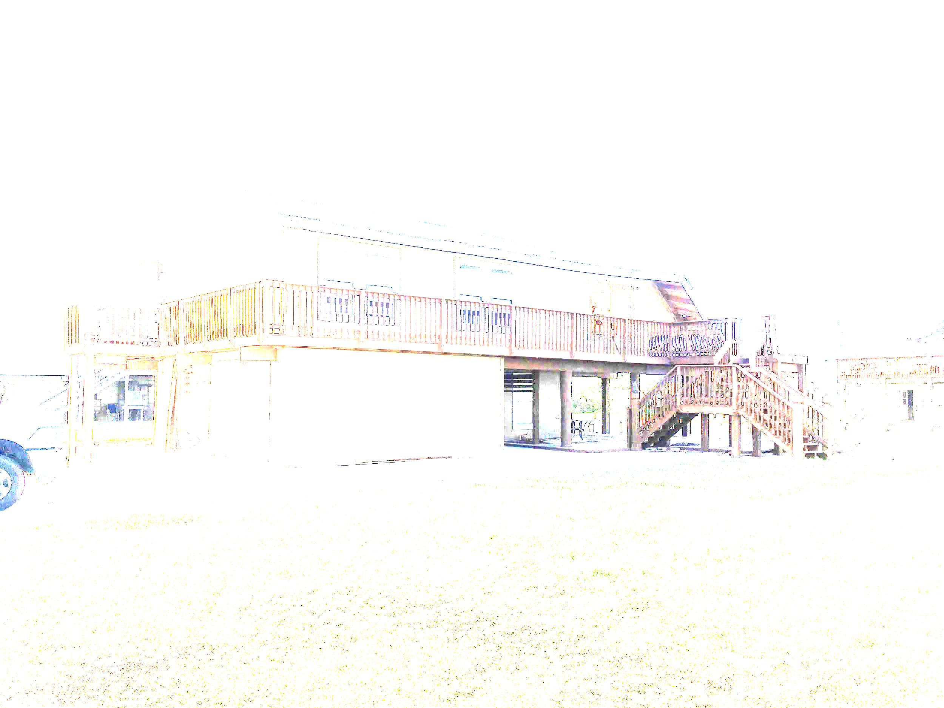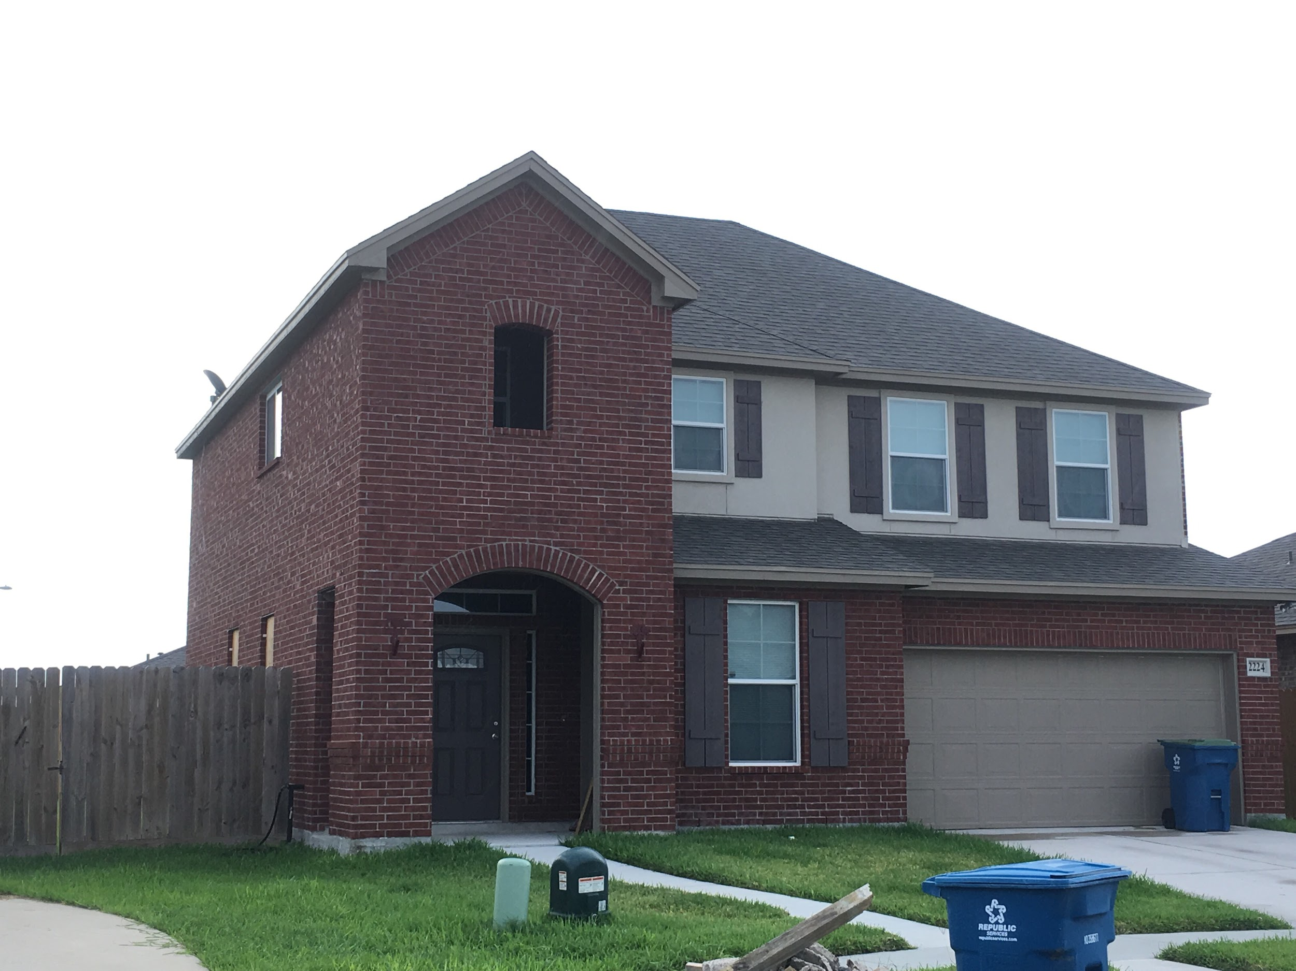

### Guidelines

Use the photographs to identify the number of stories. It’s possible to have half a story for homes that have living spaces in the attic but do not have a full second floor.

## Roof Shape

### Description

Multiple-choice input defining the shape of the roof. More than one shape may be present. Select all that apply.

### Options

Roof shape options in the app include gable, hip, hip/gable, flat, complex, gambrel and other. Figure 2 shows the basic roof shapes for guidance.

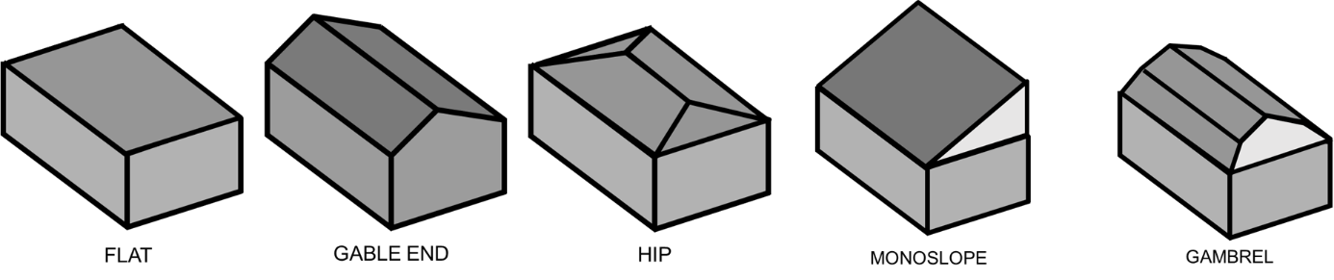

*Figure 2. Common roof shapes*

### Guidelines

Roof shapes can be quite varied. If the majority of the roof structure fits a certain roof shape, use that shape. Use the hip/gable option if the roof shape is simple but has both hip and gable elements. Use complex if multiple hips, gables, and intersections are present in the same roof structure. For example, in the roof below, hip could be considered the dominant roof shape but a large intersecting gable is present as well as a smaller gable above the front entry door. Classify this as a complex roof.

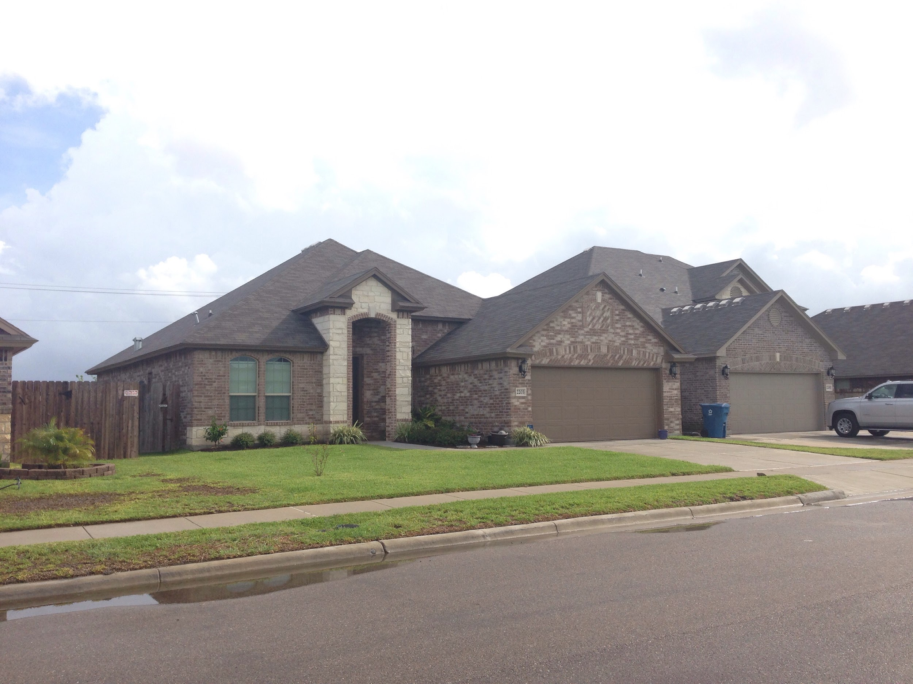

## Roof Cover

### Description

Multiple-choice input that defines that type of roof cover used on the building.

### Options

Roof cover options include the following:

|  |  |
| --- | --- |
| Asphalt Shingles (laminated) Image result for laminated asphalt shingle | Asphalt Shingles (3-tab)  Image result for 3-tabasphalt shingle |
| Metal Shingle  Image result for metal shingle | Standing Seam Metal (no fasteners visible)  Image result for standing seam metal roof |
| Corrugated Metal (fasteners visible)  Image result for corrugated metal roof | Tile (clay)  Image result for clay tile roof |
| Tile (concrete)  Image result for concrete tile roof | Slate  Image result for slate roof |

### Guidelines

Select the roof cover type that best matches that seen in the photographs. Note that more than one roof cover material may be present. Use “Other” and input a value if a unique roof cover type is present. The tax appraiser website can be used to verify the choice as well. If you cannot tell the difference between similar materials from the photos, aerials, pre-event imagery, and property appraisal data, then make an educated guess.

## Wall Cladding

### Description

Multiple-choice field that defines the wall cladding material. Choose all that apply.

### Options

The figures below illustrate the most common wall cladding options.

|  |  |
| --- | --- |
| Brick Veneer | Stucco |
| Vinyl Siding | Wood plank siding |
| Wood panel siding | Sheet metal  Image result for Metal Building Siding |
| EIFS |  |

### Guidelines

Use “Other” to input any wall cladding systems that are not captured in the common options. It is not always easy to determine the wall cladding type from photographs alone. For example, stucco and EIFS systems can look identical from the exterior. Horizontal wood planks and vinyl siding can also look identical from photographs. Comparison against the county property appraiser website is strongly recommended.

## Structural Framing System

### Description

The structural framing system is a multiple choice field that describes the Main Wind Frame Resisting System (i.e., the structural skeleton) of the building.

### Options and Guidelines

* Wood-frame - also called simply “Frame” in county records. Consists of repetitive, closely-spaced wood studs forming walls with attached wood sheathing.
* Masonry block (unreinforced) - also called concrete block. May sometimes be listed as C.B. in county records. If portions of the masonry block walls are crumbled with no evidence of vertical rebars, you can assume unreinforced.
* Masonry block (Reinforced) - also called concrete block. May sometimes be listed as C.B. in county records. Includes vertical steel rebar through masonry blocks and horizontal steel rebar through lintels and tie-beams. Reinforcement is not typically visible. Only use if rebar is clearly visible in photographs or identified by surveyor.
* Masonry block (unknown) - use if the reinforcement cannot be determined.
* Reinforced concrete - solid concrete walls with steel reinforcement.
* Structural steel - steel moment frame resisting systems, pre-engineered metal buildings.
* Cold-formed steel - similar construction style to wood-frame, with closely spaced, repetitive members, but using light-gauge steel rather than heavy structural steel.

## Opening Protection

### Description

Used to identify whether opening protection was present during the storm event. Choose all that apply.

### Options

* None
* Shutters
* Plywood/OSB
* Impact-resistant glass

### Guidelines

The Shutters option should be used when a **manufactured** shutter was used to cover the windows and/or doors. These are often made of corrugated metal, but can also be made from a translucent corrugated plastic or wood. Manufactured shutters often have visible frames permanently fastened to the exterior wall into which the shutters are inserted. The plywood/osb option should be used when sheathing panels are simply fastened into the exterior wall covering the openings. Impact-resistant glass cannot be determined from photographs alone. Assumptions can be made based on location and the building code in place at time of construction, but do not make such assumptions at this stage.

## Garage Door

### Description

Indicates whether an attached garage door is present or not.

### Options

* Yes - garage door is present
* No - garage door is not present

### Guidelines

If a garage door is visible such that the garage is part of the permanent structure, choose yes. Use “Yes” even if the garage is located below the elevated first floor.

## First Floor Height (ft)

### Description

Decimal input that defines the height of the first floor above ground level. Primarily used for elevated structures. If the height was not measured in the field, use the height of known objects such as a garage or entry door, to estimate the first floor height.

### Guidelines

If not measured in the field, the height can be estimated from photographs using the standard height of a door or other object in the same depth plane of the photograph, as shown in the figure below. Note that this home should be considered a one-story elevated home, not a two-story home.

Typical garage door height ~= 7 ft

First floor height ~= 8 ft

# Number of Sides

* + 1. *Description*

Integer input field for specifying the extent of the walls of the structure that are visible in the available photographs.

* + 1. *Guidance*

Sides in this case refers to front, back, right and left sides. There should be no more than four sides visible no matter how many photographs were taken. If only one side (front, back, left or right) is visible, then input “1”.

# Damage Modes

* + 1. *Description*

Multiple-choice field that defines the source of damage, if any damage has been identified.

* + 1. *Options*
* Wind
* Flood
* Surge
* Tree
* N/A
  + 1. *Guidance*

Do not change any options that were chosen by the surveyor during the assessment. If left blank, and no damage was identified, use “N/A”. Use “Tree” only if the trunk of a tree or a large branch has landed on the structure, causing damage, and is clearly visible from photographs. Surge damage can be hard to identify from photographs alone and should not be assigned without conclusive evidence. Refer to notes in the text fields for any evidence of surge damage noted by the surveyor. If damage is present but there is no clear evidence it was caused by storm surge or trees, assume wind. Note that wind, tree and surge damage could all be present for the same structure.

* 1. **Damage Ratios**
     1. *Description*

Damage ratios define the ratio of damaged elements to the total number of elements present in the structure pre-hurricane. For example, if a home has 10 windows and 2 are damaged, the window damage ratio is 20%. Damage ratios are to be estimated in increments of 10% for eight different structure components.

* + 1. *Structural Components*
* Roof cover
* Roof sheathing
* Roof structure
* Wall cover
* Wall sheathing
* Wall structure
* Windows
* Doors
  + 1. *Guidance*

If damage ratios have been assigned in the field, do not change without conclusive evidence (e.g., from aerial imagery the ground surveyor did not have access to) to support the change.

Roof Damage Ratios

* Roof cover, roof sheathing and roof structure damage ratios can best be estimated from aerial imagery taken by NOAA, available at <https://storms.ngs.noaa.gov/storms/Irma/index.html#14/25.9239/-81.6728>. When using the imagery, take a screenshot of the structure being assessed (include ~50 ft of surroundings in each direction in the screenshot) and upload the photo into Fulcrum for permanent archival.
* Roof cover damage ratios should never be less than roof sheathing damage ratios which should never be less than roof structure damage ratios. In other words, if roof sheathing is removed, assume the roof cover has been removed with it.

Wall Damage Ratios

* The difficulty in wall damage ratios is often that all four sides of the structure are not captured by photographs. When this occurs, use the visible portions of the structure to assign damage ratios and we will assume that the damage ratios are similar for the unseen portions of the structure.
* Wall cover damage ratios should never be less than wall sheathing damage ratios which should never be less than wall structure damage ratios. In other words, if a wall has collapsed, assume the wall cover and wall sheathing on the collapsed wall is damaged as well.

Window and Door Damage Ratios

* Use the visible portions of the structure from photographs to estimate the percent of windows and doors that are damaged.
* A boarded up window or door does not necessarily indicate it was damaged. Building owners sometimes do not remove shutters until well after the hurricane event.
* Windows and doors are considered damaged if they are breached, meaning debris or wind pressure has created a hole through the opening allowing air and rain to pass through the building envelope. A garage door that shows evidence of debris impacts but has not collapsed should not be considered damaged by this definition.

# Water Height

Use the numeric Water Height field to define the height of observable water damage in the interior of a structure. This field will primarily be applicable in regions that experienced significant flooding or storm surge.

Look for notes by the surveyor in any of the text fields of the app. Also check for pictures showing measurements of a water line. If no information is present in the notes or pictures related to a water line, then leave the field blank.

# Can Structure Be Used for Intended Purpose

This yes or no field is intended to broadly characterize structures for the purpose of assessing the resilience of a community. The more structures there are that cannot be used for intended purpose, the more disrupted are the lives of the residents.

This field will require some judgment from the surveyor/QC personnel. If damage is Moderate or higher, it likely cannot be used for intended purpose without repair.

# Tracking QC Status in Fulcrum

A QC section has been added to the Fulcrum “Hurricane Irma” app to track the progress of the QC process. The section allows entries for a QC ID, QC Code, and QC Notes.

### QC ID

This text-entry form will contain the name of the person performing the QC check.

### QC Code

This single-choice form will identify what stage the QC process is at, based on the following codes defined in Table 2.

**Table 3. QC Codes and Descriptions**

|  |  |
| --- | --- |
| **Code** | **Description** |
| 0 | No QC performed |
| 1a | Stage 1 – completed, no errors identified |
| 1b | Stage 1 – completed, errors identified and corrected |
| 1c | Stage 1 – incomplete, errors identified but not resolved |
| 2a | Stage 2 – completed, damage ratios added, visible building details added |
| 2b | Stage 2 – completed, but some fields are blank and need further review |

### QC Notes

Use this text-entry form to identify any relevant information beyond the QC Code. This form should particularly be used if EC9 or UC9 codes are used, to identify what fields need further review.